Witches' Hats
By: Amanda Formaro
Difficulty: Very Easy
Age: 5 and up
Average User Rating:

- 1
- 2
- 3
- 4
- 5
(0/5)
Parental supervision is recommended
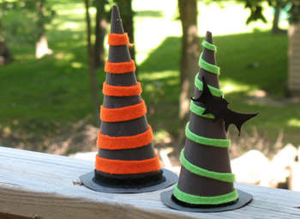
Click to view larger

- 2 sheets of black construction paper
- 1 sheet felt (green, orange, purple, or red)
- Strip of black felt
- White craft glue
- Scissors
- Tape

How to make it:
- Roll 1 sheet of black paper into a cone. Secure with tape (see image).
- Trim the bottom of the cone so that it will stand up on the table.
- Use a cup or jar as a guide and cut out a circle from black paper large enough for the hat brim.
- Glue the cone to the circle and set aside to dry (see image).
- Cut ¼” or ½” strips of felt and glue them around the cone.
- Cut a strip of black felt to go around the base of the cone.
- If you like, cut a bat out of black felt and glue to your hat.

Tips:
- Buy construction paper at the dollar store for plenty of fun projects.
- Felt is inexpensive so stock up on 5 or 6 sheets each time you go to the store.
- Traditional Halloween colors include black, orange, purple, red and green. However, you can use whatever colors you like for this project!
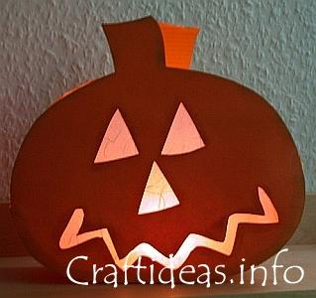
Supplies needed:
- Orange cardstock
- orange corrugated cardboard
- white fiber paper
- scissor
- craft knife
- stylus for scoring
- brown craft chalk if desired
- thick craft glue
- stick glue
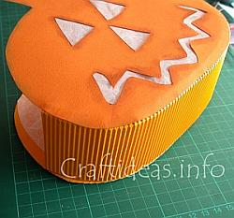
Instructions:
1. Print and trace the pattern out as large as possible twice onto orange cardstock.
2. Cut the pumpkins out using the scissors and then cut the eyes, nose and mouth out using the craft knife. Chalk the edges around the facial features and the outside edge with brown chalk if desired.
3. Cut 2 sheets of fiber paper to fit behind the facial features and use the stick glue to adhere them on the backsides of the pumpkin pieces.
4. Cut a 35 x 8 cm piece of orange corrugated cardboard perpendicular to the corrugation. This will make it easy to bend. This will be the base of the pumpkin.
5. Score a line 1 cm from the edge on each long side of the corrugated cardboard and cut slits at 2 cm intervals from the edge to the scored line.
6. Place glue along the cut slits and adhere the strip to the backside of the first pumpkin piece. When finished, do the same for the other side as well.
7. Use a tea light candle for this decoration.

pumpkin placecards
November 6, 2007
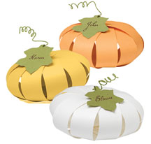
In my constant quest to do craft on the cheap, I’m not afraid to try and recreate for free for what others overcharge for. I would like to think of myself as the “Robin Hood of Crafts.” For example: Paper-Source’s paper pumpkin placecards. You could pay the $12.50 + shipping for the kit or you can just download the templates that I made and get the job done for less than $6.00.
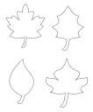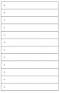
lampiónik?
